# Food Store design

<https://www.youtube.com/watch?v=bHelfhgSN2c>

## Design 1

This architecture uses cloud foundry resources with **Spring, Elastic ecosystems** along with **Observability tools.**

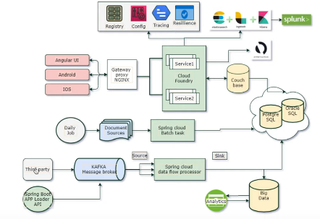

**App dynamics –** used to monitor the microservices

**Spring cloud foundry** provides **Registry, Config server, Tracing, Resilience** system.